Overview
Power BI Desktop

Churned by Churn Reason Shurn by category
$31
Ave Mon Charge

26.86%
Chern rate

1796
Total cherned

6687
Total Customers

Competitor made better offer
303
Churn Category Attitude Competitor Dissatisfaction Other Price

Competitor had better devices Attitude of support person
Don't know Competitor offered more data
Competitor offered higher download s…
Attitude of service provider
Price too high Product dissatisfaction Network reliability

203
123
110
95

84
74
73
69
0 200
11%
0%
297
11%
0%

16%

0%
0% 16%
0%

45%

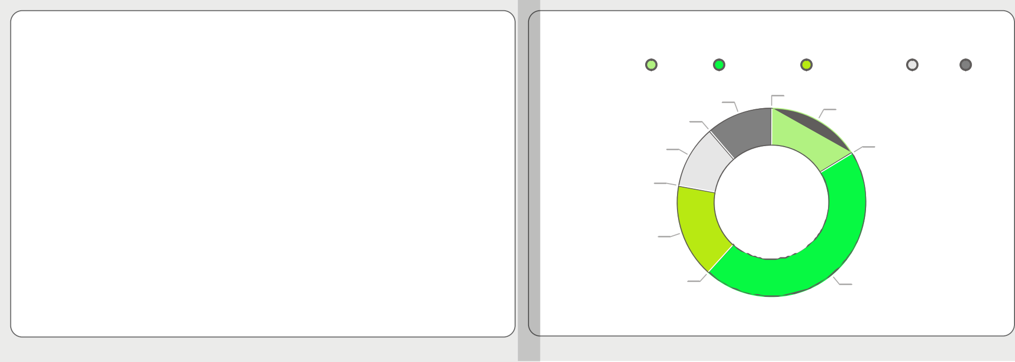

Churn rate by state

© 2026 Miiccrrossofftt Corrporrattiion

Demographics
Power BI Desktop

800

Total Customers and Chern rate by Age (bins)

60%

Churn by Demographics
100%

Monthly

600
Total Customers

400

200

563

674

552 599 619

694

548 595 537

474

301 277
4144

179

40%

20%

Other Under 30 Senior

46.29%
Chern rate

Yearly
6.62%
1287
Chern rate

0
15 20 25 30 35 40 45 50 55 60 65 70 75 80 85

Age (bins)

30.3%
1256
Chern rate

Average of Monthly Charge and Chern rate by Number of Customers in Group and Group
Chern rate and Total Customers by Contract category and Gender

$40
Average of Monthly Charge

$20
40%

20%

40%

20%
Chern rate

47%

45%
Chern rate

40%

$0

2 6 4 3

0% 0%

5 0

Monthly
6% 7%

Yearly

Number of Customers in Group Contract category

Int & Data Plane
Power BI Desktop

Churn rate by state
Intl Active | no | yes | Total
 |  |  | 
Yes | 40.34% | 7.59% | 34.31%
No | 20.01% | 71.19% | 22.21%
Total | 27.07% | 24.88% | 26.86%

Churn rate by Customer Service Calls

88%
100%
100%

31%
Chern rate
37%

9%
0 1 2 3 4 5

Customer Service Calls

© 2026 Miiccrrossofftt Corrporrattiion

